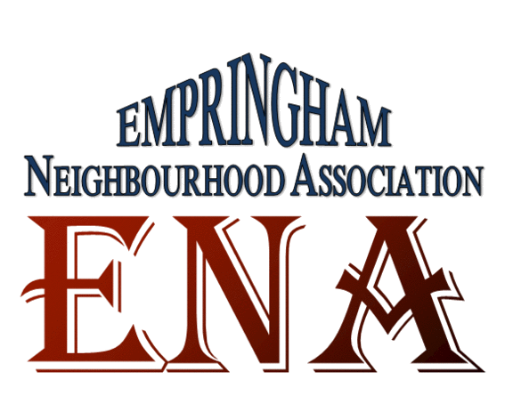
Empringham Neighbourhood Association
Resident Meeting
Monday, April 13th, 2015

AGENDA

- Welcome and Introductions

- Ground Rules : Do not cut people off; Wait for your turn, Listen, Be polite/respectful, flexible and Open-minded, agree to disagree, scent free,

- Review of Agenda
- Brief introduction of the agenda for the day

- Review of Minutes
- Minutes of ENA’s first meeting which was on March 2nd, was briefly outlined

- Resident Engagement
- Workshop on Fire Prevention and Safety: Drew from Toronto Fire Department.

- Tenant Rep Updates

- Committee Updates

- Other Business:

- Next Meeting Date: (every 2nd Monday of the Month, 6 – 8)  - Meeting May 11th  - Meeting June 8th |   

