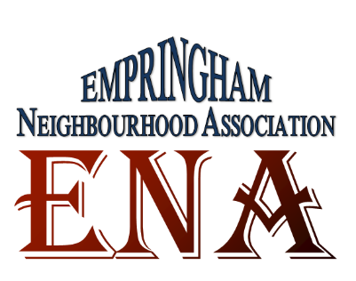
Empringham Neighbourhood Association
Monthly Meeting
Monday, April 13th, 2015

MINUTES
- Welcome and Introductions
Present:

- ENA – Empringham Neighbourhood Association  ENA is an association of the residents of 50, 90 and 110 Empringham for the residents and by the residents. The purpose of the association is to bring more services and programs into the community, promote healthy living, and connect residents with different agencies and association in the community and to organize monthly meetings and educational workshops and presentations.  There will be a regular meeting of ENA the second Monday of each month 6pm to 8 at HOPE Centre located at 212-110 Empringham Drive and further meetings and workshops will be introduced as and when required and identified. | Yama Arianfar
- Resident Engagement
- Workshop on Fire Prevention and Safety presented by Drew from Toronto Fire Department.
- How to prevent a fire and take measures to safeguard yourself and your family
- How to identify fire hazards and keep your household free from these hazards
- How to prepare a scape plan in case of fire.

- Other Business:

- Next Meeting Date: (every 2nd Monday of the Month, 6 – 8)  - May 11th |   

